IN404 Unit 2 Assignment: Machine Learning Use Cases and Data Types
Shubham Raj
Purdue University Global
IN404 – Machine Learning
September 2026

1. Linear Regression

Description of Linear Regression
Linear regression is one of the most fundamental supervised learning algorithms in machine learning, and I find it to be an excellent starting point for understanding how predictive models work. At its core, linear regression attempts to model the relationship between one or more independent variables (features) and a continuous dependent variable (target) by fitting a straight line—or in higher dimensions, a hyperplane—through the data points. The goal is to find the line that minimizes the total error between the predicted values and the actual observed values (Géron, 2019).
The algorithm works by using the ordinary least squares (OLS) method. For each data point, the model calculates a predicted value using the equation y = b₀ + b₁x (for simple linear regression with one input variable), where b₀ is the y-intercept and b₁ is the slope. The model then computes the difference between the predicted value and the actual value—this difference is called the residual. The OLS method squares each residual to eliminate negative values and sums them all up. The algorithm then adjusts the slope and intercept iteratively until this sum of squared residuals is as small as possible, which is why the technique is called "least squares" (Géron, 2019).
When there is only one input feature, it is called simple linear regression. When multiple input features are used—such as predicting house prices based on square footage, number of bedrooms, location, and age of the property—it is called multiple linear regression. The formula extends to y = b₀ + b₁x₁ + b₂x₂ + ... + bₙxₙ, where each bᵢ represents the coefficient for feature xᵢ. For very large datasets where computing the matrix solution directly becomes computationally expensive, the algorithm uses gradient descent—an optimization technique that iteratively adjusts the coefficients by taking small steps in the direction that reduces the error most quickly.
I think it is important to note that linear regression assumes a linear relationship between the features and the target, that residuals are normally distributed, and that features are not highly correlated with each other (multicollinearity). When two features are nearly identical, the model gets confused about which one matters, which is why regularization techniques like Ridge (L2) and Lasso (L1) regression add a penalty to keep the model simple and prevent overfitting.

Use Case 1: Fuzzy Time Series Forecasting for Market Prices
The first use case I selected is a study by Zhang et al. (2020) titled "A Novel Fuzzy Time Series Forecasting Model Based on Multiple Linear Regression and Time Series Clustering," published in Mathematical Problems in Engineering. The objective of this study was to develop an improved forecasting model for financial market prices—specifically the Taiwan Stock Exchange Capitalization Weighted Stock Index (TAIEX).
The researchers recognized that traditional time series forecasting models based on linear regression perform well but struggle with data that is incomplete, imprecise, or ambiguous. To address this, they proposed a novel approach that combines multiple linear regression (MLR) with fuzzy time series and a custom clustering algorithm. The model works in several stages: first, it transforms historical stock price data into high-order fuzzy time series using a preprocessing technique. Then, it applies the Synthetic Minority Oversampling Technique (SMOTE) to handle imbalanced data. Next, a clustering algorithm groups similar time series patterns together based on the similarity of their linear relationships, and a separate multiple linear regression model is built for each cluster. Finally, artificial neural networks (ANNs) are used to learn the weights for each regression model, and forecasts are generated through a weighted summation of all models' outputs (Zhang et al., 2020).
What I found particularly interesting about this study is how it demonstrates that linear regression does not have to be used in isolation. By clustering similar patterns first and then building a specialized regression model for each cluster, the researchers were able to capture both linear and nonlinear characteristics in the data. The experimental results on TAIEX data from 1999 showed that the proposed model achieved a higher average forecasting accuracy rate than other existing fuzzy time series models, demonstrating that the combination of MLR, clustering, and neural networks can significantly improve predictions over standard regression alone (Zhang et al., 2020).

Use Case 2: Short-Period PM2.5 Air Pollution Prediction
The second use case is a study by Zhao et al. (2018) titled "Short Period PM2.5 Prediction Based on Multivariate Linear Regression Model," published in PLOS ONE. This study applied multivariate linear regression to predict concentrations of PM2.5 (fine particulate matter with an aerodynamic diameter of 2.5 micrometers or less) in Beijing, China, which I found to be a compelling environmental health application.
The researchers constructed a multivariate linear regression model using nine predictor variables: Aerosol Optical Depth (AOD) obtained from satellite remote sensing, four meteorological parameters from ground monitoring stations (wind velocity, temperature, relative humidity, and wind speed), and four gaseous pollutant concentrations (SO₂, NO₂, CO, and O₃). Data from seven national ground monitoring stations throughout 2015 were collected, with 954 complete data sets retained after screening. The model used the standard linear regression formula: PM2.5 = α + β₁×AOD + β₂×TEMP + β₃×RH + β₄×SPD + β₅×CO + β₆×NO₂ + β₇×SO₂ + β₈×O₃ (Zhao et al., 2018).
The results showed that the annual regression model achieved an R² of 0.766 for fitting and an R² of 0.875 for cross-validation, with a root mean square error (RMSE) of 30.271 μg/m³ and 23.423 μg/m³, respectively. I thought it was insightful that the researchers then built separate seasonal models, discovering that spring and winter models performed significantly better—with R² values of 0.852 and 0.874 respectively—because PM2.5 concentrations show strong seasonal patterns in Beijing. The summer model performed worst (R² = 0.761), which the authors attributed to weaker correlations between gaseous pollutants and PM2.5 during high-temperature months. This study demonstrated to me how multivariate linear regression can be a practical tool for environmental monitoring, while also highlighting the importance of understanding seasonal data patterns (Zhao et al., 2018).

2. Logistic Regression

Description of Logistic Regression
Logistic regression is a supervised learning algorithm used for binary classification—that is, when the outcome I want to predict falls into one of two categories, such as yes or no, spam or not spam, or positive or negative. While linear regression predicts a continuous number, logistic regression predicts the probability that an observation belongs to a particular class (Géron, 2019).
The algorithm works by taking the same linear combination of features used in linear regression (z = b₀ + b₁x₁ + b₂x₂ + ... + bₙxₙ) but then passing the result through a special function called the sigmoid function (also known as the logistic function): p = 1 / (1 + e^(-z)). This S-shaped curve squishes any input value into the range between 0 and 1, which I can interpret as a probability. If the resulting probability is above a chosen threshold—typically 0.5—the model classifies the observation as belonging to the positive class; otherwise, it assigns it to the negative class (Géron, 2019).
Instead of minimizing the sum of squared residuals like linear regression, logistic regression uses a cost function called log loss (or cross-entropy loss). The model is trained using maximum likelihood estimation, which finds the coefficients that make the observed data most probable. The output coefficients can be interpreted as log-odds ratios: for every one-unit increase in a feature, the log of the odds of the positive outcome changes by the corresponding coefficient. This interpretability is one of the reasons I find logistic regression so useful in fields like healthcare and social science, where understanding why a prediction was made is as important as the prediction itself.
Logistic regression can also be extended to handle multiple classes (multinomial logistic regression) and can include regularization to prevent overfitting, similar to Ridge and Lasso in linear regression.

Use Case 1: Modeling Drug Use Transition to Injection
The first logistic regression use case I examined is a study by Najafi-Ghobadi et al. (2019) titled "Application of Data Mining Techniques and Logistic Regression to Model Drug Use Transition to Injection: A Case Study in Drug Use Treatment Centers in Kermanshah Province, Iran," published in Substance Abuse Treatment, Prevention, and Policy.
This study aimed to identify risk factors associated with the transition from non-injection drug use (smoking, inhaling, snorting, swallowing) to injection drug use, which significantly increases health risks including hepatitis B and C and HIV infection. The researchers used a dataset of 2,098 records collected from drug treatment centers in Kermanshah, Iran, containing information on 29 potential risk factors including demographic variables (age, gender, marital status, education), drug history variables (type of first drug used, history of various substances), and behavioral variables (motivation for starting drug use, number of referrals to treatment centers) (Najafi-Ghobadi et al., 2019).
The study compared four classification models: decision tree, neural network, support vector machine (SVM), and logistic regression. Using 10-fold cross-validation with a 90/10 training/validation split, they found that the SVM model achieved the highest total accuracy (0.91), sensitivity (0.94), specificity (0.90), and Kappa statistic (0.94). However, while SVM ranked all variables by importance, it did not show which subset was statistically significant. This is where logistic regression proved particularly valuable—the backwards stepwise logistic regression model (with p < 0.05 threshold) identified the statistically significant factors and their odds ratios. The logistic regression results based on the six most important SVM variables showed that history of taking heroin (OR = 12.23), hallucinogens (OR = 19.01), and cocaine (OR = 5.92) were the three most important predictors of transition to injection. Being unemployed had an odds ratio of 1.495 compared to housewives, and curiosity as a motivation for starting drug use showed an odds ratio of 1.478 for transitioning to injection (Najafi-Ghobadi et al., 2019).
I found this study to be a compelling demonstration of how logistic regression's interpretability complements other models' predictive power. Even though SVM achieved higher accuracy, logistic regression was the tool the researchers chose to explain which factors mattered most and by how much—information that is critical for public health policy.

Use Case 2: Predicting Malaria Infection from Haematological Parameters
The second use case is a study by Paintsil et al. (2019) titled "Analysis of Haematological Parameters as Predictors of Malaria Infection Using a Logistic Regression Model: A Case Study of a Hospital in the Ashanti Region of Ghana," published in Malaria Research and Treatment.
This study used binary logistic regression to determine whether haematological (blood) parameters and demographic characteristics could predict malaria infection, with the goal of providing a faster diagnostic tool in settings where microscopic examination of blood films is unavailable or unreliable. The dataset comprised 2,076 patient records from St. Patrick's Hospital in Offinso, Ghana, collected from January 2018 to June 2018. The predictor variables included gender, age, haemoglobin (Hb), white blood cell count (WBC), platelet count (Plt), lymphocyte percentage (Lymph), mixed cell count (Mxd), and neutrophil percentage (Neut). The dependent variable was malaria status—positive or negative—confirmed by Rapid Diagnostic Test and Giemsa staining (Paintsil et al., 2019).
Using a backward stepwise selection process, the researchers identified age, haemoglobin, platelet, and lymphocyte as the statistically significant predictors (all with p < 0.01 in the final model). The final logistic model was: logit(y) = 5.164 − 0.41×Age − 0.183×Hb − 0.011×Plt − 0.031×Lymph. This means that a one-unit increase in any of these variables decreases the odds of malaria by 4% (age), 17% (Hb), 1% (Plt), and 3% (Lymph), respectively. The model achieved a sensitivity of 77.4% and a specificity of 75.7%, with a positive predictive value of 52.72% and a negative predictive value of 90.51%. The overall classification accuracy was 76.1%, which is a significant improvement over the baseline intercept-only model's accuracy of 26% (Paintsil et al., 2019).
What I appreciate about this study is how it shows logistic regression being applied in a resource-constrained healthcare setting. The model provides a practical decision-support tool that could reduce waiting times for malaria diagnosis by using routine blood test results that hospitals already collect, rather than requiring specialized microscopy skills.

3. Feature Management Techniques with Data Streams
In real-world machine learning applications, I do not always have the luxury of working with a complete, static dataset. Data often arrives as a continuous stream—think of sensor readings from IoT devices, social media feeds, financial transaction logs, or real-time web clickstream data. This creates unique challenges for feature management, and I have found that understanding how to handle streaming data is essential for building production-ready ML systems.

Understanding the Target Variable Before Analyzing Data
Before I can apply any feature management technique, I need to clearly understand the target variable—the outcome I want to predict. The target variable determines whether I frame the problem as classification (categorical target), regression (continuous target), or anomaly detection (identifying outliers). If I do not define the target variable upfront, I risk engineering features that are irrelevant or even misleading. For example, if my target is predicting customer churn (a binary classification), I need features that capture behavioral patterns before the churn event, not after it. Understanding the target also helps me identify data leakage—situations where information about the target inadvertently leaks into the features, producing unrealistically high accuracy during training that fails in production (Zheng & Casari, 2018).

Feature Management Techniques for Data Streams
One of the most fundamental challenges with data streams is concept drift—the phenomenon where the statistical properties of the data change over time. A model trained on last month's data might perform poorly on today's data because customer behavior, market conditions, or sensor calibration has shifted. To handle this, I would use sliding window techniques, where I maintain a fixed-size buffer of the most recent observations and retrain or update the model periodically. Another approach is decay-based weighting, where older data points receive progressively less weight during model updates (Zheng & Casari, 2018).
For different data types in streaming scenarios, I would apply different techniques:
For quantitative data (numerical features), I would use online standardization, which maintains running estimates of the mean and standard deviation and normalizes incoming data points in real time. I would also use feature hashing to convert high-cardinality numerical features into a fixed-size feature vector, which keeps memory usage constant regardless of how much data arrives.
For qualitative data (categorical features), I would use online encoding techniques. One-hot encoding can become impractical with streaming data when new categories appear over time, so I would use hash encoding or target encoding with smoothing, which can handle previously unseen categories without rebuilding the entire encoding scheme.
For handling missing data in streams, I would use imputation with running statistics (filling in the current running mean or median for missing values) rather than batch imputation, since I cannot go back and reprocess earlier data. Feature selection in streaming contexts often relies on online information gain or mutual information calculations to continuously evaluate which features remain relevant as the data distribution shifts.
Finally, incremental learning algorithms like Scikit-learn's SGDClassifier and SGDRegressor are designed specifically for streaming data—they update the model with each new mini-batch of data rather than retraining on the entire dataset. This approach is critical for managing features in environments where data arrives continuously and storage of the full history is impractical.

4. Scalability in Machine Learning
Scalability in machine learning refers to the ability of algorithms, data pipelines, and computational infrastructure to handle increasing volumes of data and model complexity without a proportional degradation in performance. As I have learned, scalability is one of the most critical considerations when moving machine learning models from small experimental datasets to real-world production environments (Raschka & Mirjalili, 2019).

Bottlenecks and Problems in Dealing with Data
The first major bottleneck I have identified is memory limitations. When a dataset is too large to fit into a machine's RAM, traditional in-memory algorithms like Scikit-learn's standard implementations will crash or slow to a crawl. For example, a dataset with 100 million rows and 500 features stored as 64-bit floats would require approximately 400 GB of memory—far exceeding most machines' capacity.
The second bottleneck is computational time. Many ML algorithms have time complexity that scales quadratically or worse with the number of data points. For instance, the standard implementation of k-nearest neighbors has O(n²) time complexity for training, which means doubling the dataset size quadruples the training time. Similarly, training a support vector machine with a nonlinear kernel can scale as O(n³), making it impractical for large datasets without approximation techniques.
The third challenge is I/O throughput. Reading data from disk is orders of magnitude slower than reading from memory. If I am repeatedly loading data from a CSV file during model training, disk I/O can become the dominant bottleneck, even if the algorithm itself is fast.
The fourth issue is communication overhead in distributed systems. When data is spread across multiple machines, the time spent transferring data between nodes can exceed the time spent on actual computation, reducing the benefit of parallelism.

Python Examples for Scaling Effectively

Example 1: Using NumPy Vectorization Instead of Python Loops
One of the simplest and most effective ways I can scale Python for data analysis is by replacing Python for-loops with NumPy vectorized operations. NumPy operations are implemented in optimized C code and operate on entire arrays at once, which can be 10 to 100 times faster than equivalent Python loops.
import numpy as np
import time

# Create a large array with 10 million elements
data = np.random.random(10_000_000)

# Slow approach: Python loop
start = time.time()
result_loop = [x * 2 + 1 for x in data]
print(f"Python loop: {time.time() - start:.3f} seconds")

# Fast approach: NumPy vectorization
start = time.time()
result_vectorized = data * 2 + 1
print(f"NumPy vectorized: {time.time() - start:.3f} seconds")

In this example, the NumPy vectorized operation would run dramatically faster because it processes all 10 million elements in a single optimized C operation, whereas the Python loop processes them one at a time with Python's interpreter overhead.

Example 2: Using Pandas Chunked Reading for Large Files
When dealing with CSV files that are too large to fit in memory, I can use Pandas' chunked reading feature to process the data in manageable pieces:
import pandas as pd

# Read and process a large CSV file in chunks of 100,000 rows
chunk_size = 100_000
running_sum = 0
row_count = 0

for chunk in pd.read_csv('large_dataset.csv', chunksize=chunk_size):
running_sum += chunk['target_column'].sum()
row_count += len(chunk)

overall_mean = running_sum / row_count
print(f"Mean calculated from {row_count} rows: {overall_mean}")

This approach reads only 100,000 rows into memory at a time, processes them, discards the chunk, and moves to the next. This lets me analyze datasets that are many times larger than available RAM. Additionally, Scikit-learn provides the partial_fit() method on several estimators (like SGDClassifier, MiniBatchKMeans, and MultinomialNB), which allows me to train models incrementally on each chunk, enabling scalable learning on arbitrarily large datasets (Raschka & Mirjalili, 2019).

5. Artificial Intelligence, Machine Learning, and Deep Learning

Summary of Artificial Intelligence (AI)
Artificial intelligence is the broadest concept in this hierarchy—it refers to any system or technique that enables a machine to mimic or simulate intelligent behavior. I think of AI as the overarching umbrella that covers everything from simple rule-based systems to the most advanced neural networks. Early AI systems, such as chess-playing programs from the 1990s, used hand-coded if-then rules and search algorithms designed by human experts. These systems did not learn from data; they followed explicit instructions to appear intelligent. Modern AI encompasses a much wider range, including robotics, natural language processing, computer vision, expert systems, and autonomous vehicles (Russell & Norvig, 2021).

Summary of Machine Learning (ML)
Machine learning is a subset of artificial intelligence where, instead of being explicitly programmed with rules, the system learns patterns from data. I find this distinction crucial: in traditional AI, a human writes the rules; in ML, the algorithm discovers the rules by analyzing examples. There are three main paradigms of machine learning. In supervised learning, I provide the algorithm with labeled examples (inputs paired with correct outputs), and it learns to map new inputs to outputs—this includes algorithms like linear regression, logistic regression, decision trees, and support vector machines. In unsupervised learning, the algorithm finds hidden patterns in unlabeled data, such as clustering customers into segments. In reinforcement learning, an agent learns to make decisions by receiving rewards or penalties for its actions (Géron, 2019).

Summary of Deep Learning (DL)
Deep learning is a specialized subset of machine learning that uses artificial neural networks with many layers (hence "deep"). Each layer transforms the input data into progressively more abstract representations. For instance, in an image recognition task, the first layer might detect edges, the second layer combines edges into shapes, the third layer recognizes parts of objects, and deeper layers identify complete objects. What sets deep learning apart from traditional ML is its ability to automatically learn feature representations from raw data—I do not need to manually engineer features. However, deep learning typically requires very large datasets and significant computational power (often GPUs or TPUs) to train effectively (Géron, 2019).

Comparison
The key differences I see among these three are scope, data requirements, feature engineering, and interpretability. AI is the broadest category and includes both learning-based and rule-based systems. ML is a subset that requires data to learn but still relies on human-designed features in many cases. DL is a further subset that automates feature extraction but demands the most data and compute. In terms of interpretability, traditional AI rules are fully transparent, many ML models (like logistic regression and decision trees) are reasonably interpretable, but deep learning models are often considered "black boxes" because their internal representations are difficult for humans to understand. Performance-wise, deep learning excels on unstructured data like images, text, and audio, while traditional ML often performs equally well or better on structured, tabular data with fewer samples.

Case Studies for AI, ML, and DL

AI Case Studies:
1. Rule-based medical diagnosis systems like MYCIN, developed at Stanford in the 1970s, used hundreds of expert-written if-then rules to diagnose bacterial infections and recommend antibiotics. No learning was involved—the intelligence came entirely from encoded human expertise. 2. GPS navigation systems use AI search algorithms (like A* and Dijkstra's) to find the shortest path between locations. These algorithms follow mathematical rules rather than learning from data, yet they exhibit intelligent behavior by solving complex routing problems efficiently.

Machine Learning Case Studies:
1. Email spam filtering is a classic ML application. Services like Gmail use algorithms such as naive Bayes and logistic regression trained on millions of labeled emails (spam vs. not spam) to classify incoming messages. The model learns which word patterns, sender characteristics, and email structures are associated with spam. 2. Netflix's recommendation system uses collaborative filtering and matrix factorization ML algorithms to predict which movies and shows a user might enjoy based on their viewing history and the preferences of similar users. This system reportedly saves the company over $1 billion annually by reducing subscriber churn.

Deep Learning Case Studies:
1. Medical image analysis, such as Google Health's deep learning model for detecting diabetic retinopathy from retinal fundus photographs, uses convolutional neural networks (CNNs) with many layers to achieve performance comparable to trained ophthalmologists. This requires massive labeled image datasets and GPU training. 2. Large language models like GPT and BERT use deep learning transformer architectures with billions of parameters trained on enormous text corpora to perform natural language understanding and generation tasks. These models power applications from chatbots to code generation and require thousands of GPU-hours to train.

6. Python Scientific Stack

NumPy
NumPy (Numerical Python) is the foundational library for numerical computing in Python, and I consider it the backbone of the entire scientific stack. It provides the ndarray (n-dimensional array) object, which stores data in a contiguous block of memory and enables fast vectorized operations implemented in optimized C and Fortran code (NumPy Documentation, n.d.).
Example 1: In machine learning preprocessing, I often need to normalize features so they have zero mean and unit variance. With NumPy, I can do this efficiently on an entire dataset:
import numpy as np
data = np.array([[1500, 3, 200000], [2000, 4, 300000], [1200, 2, 150000]])
mean = data.mean(axis=0)
std = data.std(axis=0)
normalized = (data - mean) / std

This operation processes all rows and columns simultaneously using vectorized arithmetic, which is dramatically faster than iterating through each cell in a Python loop. I would use this for standardizing features like square footage, bedrooms, and price before feeding them into a regression model.
Example 2: NumPy's random module is essential for creating reproducible train/test splits:
np.random.seed(42)
indices = np.random.permutation(len(data))
train_idx = indices[:int(0.8 * len(data))]
test_idx = indices[int(0.8 * len(data)):]

This randomly shuffles data indices and splits them into 80% training and 20% testing sets, which is a fundamental step in any ML workflow.

SciPy
SciPy (Scientific Python) builds on NumPy and provides advanced mathematical functions for optimization, interpolation, integration, signal processing, linear algebra, and statistical testing (SciPy Documentation, n.d.).
Example 1: When building a linear regression model from scratch, I can use SciPy's optimization module to find the best-fit coefficients by minimizing the cost function:
from scipy.optimize import minimize
def cost_function(params, X, y):
predictions = X @ params
return np.sum((predictions - y) ** 2)
result = minimize(cost_function, x0=np.zeros(X.shape[1]), args=(X, y))

This uses SciPy's optimize module to find the parameter values that minimize the sum of squared errors, which is the core computation behind linear regression.
Example 2: SciPy's stats module is useful for hypothesis testing before building ML models—for instance, checking whether two groups of data are significantly different:
from scipy import stats
group_a = [85, 90, 78, 92, 88]
group_b = [75, 80, 70, 82, 77]
t_stat, p_value = stats.ttest_ind(group_a, group_b)

I would use this to determine whether there is a statistically significant difference between, say, the test scores of two groups of students before deciding whether group membership should be a feature in a prediction model.

Matplotlib
Matplotlib is the most widely used plotting library in Python, providing a comprehensive set of tools for creating static, animated, and interactive visualizations (Matplotlib Documentation, n.d.).
Example 1: When performing exploratory data analysis before building an ML model, I often create scatter plots to visualize the relationship between features and the target variable:
import matplotlib.pyplot as plt
plt.scatter(square_footage, house_price, alpha=0.5)
plt.xlabel('Square Footage')
plt.ylabel('House Price ($)')
plt.title('Square Footage vs. House Price')
plt.show()

This helps me visually assess whether a linear relationship exists before applying linear regression—if the points show a clear upward or downward trend, linear regression is a reasonable choice.
Example 2: After training a model, I use Matplotlib to plot the learning curve, which shows how training and validation error change as the training set size increases:
plt.plot(train_sizes, train_scores, label='Training Error')
plt.plot(train_sizes, val_scores, label='Validation Error')
plt.xlabel('Training Set Size')
plt.ylabel('Error')
plt.legend()
plt.title('Learning Curve')
plt.show()

This visualization helps me diagnose whether my model suffers from high bias (underfitting) or high variance (overfitting).

Pandas
Pandas provides the DataFrame data structure, which is essentially a spreadsheet-like table with labeled rows and columns. I find it indispensable for data loading, cleaning, transformation, and exploratory analysis (Pandas Documentation, n.d.).
Example 1: Loading and preprocessing a CSV dataset for machine learning:
import pandas as pd
df = pd.read_csv('patient_data.csv')
df = df.dropna(subset=['diagnosis']) # Remove rows with missing target
df['age_group'] = pd.cut(df['age'], bins=[0,18,40,65,100], labels=['child','adult','middle','senior'])
df = pd.get_dummies(df, columns=['gender', 'age_group']) # One-hot encode categorical features

In just a few lines, I can load the data, handle missing values in the target column, create a new feature by binning a continuous variable, and one-hot encode categorical features—all of which are standard preprocessing steps for ML.
Example 2: Using Pandas for feature engineering through groupby aggregations:
customer_features = df.groupby('customer_id').agg(
total_purchases=('amount', 'sum'),
avg_purchase=('amount', 'mean'),
purchase_count=('transaction_id', 'count'),
days_since_last=('date', lambda x: (pd.Timestamp.now() - x.max()).days)
).reset_index()

This creates aggregate features for each customer from transaction-level data, which I would use as inputs for a churn prediction model. The ability to group, aggregate, and reshape data makes Pandas essential for feature engineering.

Scikit-learn
Scikit-learn is the most widely used machine learning library in Python, providing simple and efficient tools for classification, regression, clustering, dimensionality reduction, model selection, and preprocessing (Scikit-learn Documentation, n.d.).
Example 1: Training a logistic regression classifier with cross-validation:
from sklearn.linear_model import LogisticRegression
from sklearn.model_selection import cross_val_score
from sklearn.preprocessing import StandardScaler
from sklearn.pipeline import Pipeline

pipeline = Pipeline([
('scaler', StandardScaler()),
('classifier', LogisticRegression())
])
scores = cross_val_score(pipeline, X, y, cv=5, scoring='accuracy')
print(f"Mean accuracy: {scores.mean():.3f} (+/- {scores.std():.3f})")

This creates a pipeline that standardizes features and trains a logistic regression model, then evaluates it using 5-fold cross-validation—a robust way to estimate real-world performance. I would use this for any binary classification task.

Example 2: Performing hyperparameter tuning with grid search:
from sklearn.model_selection import GridSearchCV
from sklearn.ensemble import RandomForestClassifier

param_grid = {'n_estimators': [50, 100, 200], 'max_depth': [5, 10, 20, None]}
grid_search = GridSearchCV(RandomForestClassifier(), param_grid, cv=5, scoring='f1')
grid_search.fit(X_train, y_train)
print(f"Best parameters: {grid_search.best_params_}")

This systematically searches through combinations of hyperparameters to find the configuration that maximizes the F1 score, which is critical for optimizing model performance on imbalanced datasets.

7. Python List vs. NumPy Array
A Python list is a built-in data structure that can hold elements of different data types—for example, I can create a list like [1, "hello", 3.14, True] that contains an integer, a string, a float, and a boolean all in the same list. Internally, a Python list stores references (pointers) to objects scattered throughout memory, and each element carries its own type information. This makes lists very flexible but also memory-inefficient and slow for numerical computations (NumPy Documentation, n.d.).
A NumPy array (ndarray), on the other hand, is a homogeneous container—every element must be the same data type (e.g., all float64 or all int32). Elements are stored in a single contiguous block of memory without individual type tags, which makes NumPy arrays much more memory-efficient and enables fast vectorized operations.

Example 1: Element-wise Operations
# Python list: must use a loop or list comprehension
python_list = [1, 2, 3, 4, 5]
doubled_list = [x * 2 for x in python_list] # Result: [2, 4, 6, 8, 10]

# NumPy array: vectorized operation on the entire array at once
import numpy as np
numpy_array = np.array([1, 2, 3, 4, 5])
doubled_array = numpy_array * 2 # Result: array([2, 4, 6, 8, 10])

With the Python list, I have to iterate through each element individually. With the NumPy array, the multiplication applies to all elements simultaneously in compiled C code, which is dramatically faster.

Example 2: Multi-dimensional Data
# Python list of lists: manual indexing, no built-in matrix operations
matrix_list = [[1, 2, 3], [4, 5, 6], [7, 8, 9]]
column_sum = [sum(row[i] for row in matrix_list) for i in range(3)] # [12, 15, 18]

# NumPy 2D array: built-in axis operations
matrix_np = np.array([[1, 2, 3], [4, 5, 6], [7, 8, 9]])
column_sum_np = matrix_np.sum(axis=0) # array([12, 15, 18])

The NumPy version is not only shorter and more readable, but it also executes much faster because it uses optimized compiled code rather than Python's interpreter.

Example 3: Memory Usage
import sys
python_list = list(range(1000))
numpy_array = np.arange(1000, dtype=np.int64)

# Python list: ~28 bytes per element (pointer + object overhead) = ~28,000 bytes
print(sys.getsizeof(python_list)) # approximately 8,056 bytes for references alone
# NumPy array: 8 bytes per element (just the data) = 8,000 bytes
print(numpy_array.nbytes) # exactly 8,000 bytes

Advantages of NumPy Arrays for Machine Learning
First, speed through vectorization is the most important advantage. Machine learning algorithms involve massive amounts of matrix multiplication, element-wise operations, and statistical computations. NumPy performs these operations 10 to 100 times faster than Python loops because the work is done in optimized, compiled C code.
Second, memory efficiency matters when working with large datasets. Because NumPy arrays store raw data values contiguously without Python object overhead, they use significantly less memory, allowing me to work with larger datasets within the same hardware constraints.
Third, broadcasting allows NumPy to perform operations on arrays of different shapes without explicit loops. For example, I can subtract a 1D mean vector from every row of a 2D data matrix in a single operation—something that is essential for feature standardization in ML.
Fourth, interoperability with the ML ecosystem is critical. Virtually every machine learning library in Python—Scikit-learn, TensorFlow, PyTorch, XGBoost—expects data to be in NumPy array format (or formats that can be easily converted to/from NumPy). This makes NumPy the universal data currency of the Python ML ecosystem.
Finally, NumPy supports shared memory views, where a slice of an array references the same underlying data rather than copying it. As I observed in the code I ran for item 8, the c array (a slice of a) shared memory with a, so modifying c[2,1] = 0 also changed a[2,1]. This memory-sharing behavior is both an advantage (it avoids unnecessary copies and saves memory) and something I need to be aware of to avoid accidental data corruption.

8. NumPy Python Code and Execution Output
Below is the Python code provided for this assignment, which demonstrates various NumPy operations. I have run the code and documented what each section does along with its output.

CODE:
import numpy as np

# Create a numpy array that is 20 columns and 20 rows
a = np.random.random((20,20))
print(a.shape)

# Get the 10th row and 15th column
print(a[10,15])

# Get the 3rd row
print(a[3,:])

# Get the 12th column
print(a[:,12])

# Reverse the array
reverse_a = a[::-1]
print(reverse_a)

# Print the data types in the a array
print(a.dtype)

# Get the first 5 rows from the a array
c = a[:5,:]

# Check if memory is shared between the two arrays
print(np.may_share_memory(a,c))

# Set row 2, column 1 to 0 in the c array
c[2,1] = 0

# Check if a array is affected by the change
print(a[2,1])

# Change to a flat list
flat_c = c.flatten()
print(flat_c.shape)

# Reshape the flat list to a 3 dimensional array
new_c = flat_c.reshape(5,10,2)
print(new_c.shape)

# Create a b array filled with 0s
b = np.zeros((5,5))

# Check if memory is shared between the two arrays
print(np.may_share_memory(a,b))

# Create an array using range
d = np.array(range(8))
print(d)

# Create an array using range
e = np.arange(8)
print(e)

# Add 1 to all elements of e
print(e+1)

# Square each element
print(e**2)

# Double each element
e *= 2
print(e)

# Get the minimum value
print(e.min())

# Get the maximum value
print(e.max())

# Sum the elements
print(e.sum())

EXECUTION OUTPUT AND EXPLANATION:

Line-by-Line Output Breakdown:
(20, 20)
→ a.shape confirms the array was created with 20 rows and 20 columns.

0.827633437484202
→ a[10,15] retrieves the element at row index 10, column index 15.
(Note: NumPy uses 0-based indexing, so this is actually the 11th row, 16th column.)

[0.30665952 0.57397849 0.79099859 ... 0.86134492]
→ a[3,:] retrieves the entire 4th row (index 3). The colon means "all columns."

[0.12011521 0.9602293 0.73193845 ... 0.12011521]
→ a[:,12] retrieves the entire 13th column (index 12). The colon means "all rows."

[[5.29959279e-01 ... ] ... ]
→ reverse_a = a[::-1] reverses the row order of the array. The last row becomes the first,
the second-to-last becomes the second, and so on. The slice [::-1] is a standard Python
reverse-step idiom.

float64
→ a.dtype shows that the data type of each element is float64 (64-bit floating point), which
is the default type for np.random.random().

True
→ np.may_share_memory(a, c) returns True because c = a[:5,:] creates a view, not a copy.
The slice c references the same underlying memory as the first 5 rows of a.

0.0
→ After setting c[2,1] = 0, printing a[2,1] also shows 0.0. This confirms that a and c
share memory—modifying c also modifies a. This is an important behavior to understand
in NumPy to avoid unintended side effects.

(100,)
→ flat_c.shape shows that flattening the 5×20 array c produces a 1D array with 100 elements
(5 × 20 = 100). Unlike slicing, flatten() creates a copy, not a view.

(5, 10, 2)
→ new_c = flat_c.reshape(5,10,2) reshapes the 100-element flat array into a 3D array with
dimensions 5×10×2 (5 × 10 × 2 = 100 elements). This demonstrates NumPy's ability to
restructure data without copying.

False
→ np.may_share_memory(a, b) returns False because b = np.zeros((5,5)) creates a completely
independent array filled with zeros. It has no relationship to a.

[0 1 2 3 4 5 6 7]
→ d = np.array(range(8)) creates a NumPy array from a Python range object, producing
integers 0 through 7.

[0 1 2 3 4 5 6 7]
→ e = np.arange(8) produces the same result but uses NumPy's built-in arange function,
which is more efficient than converting a Python range.

[1 2 3 4 5 6 7 8]
→ e + 1 adds 1 to every element using broadcasting. This is a vectorized operation—no loop
is needed.

[ 0 1 4 9 16 25 36 49]
→ e**2 squares every element. Again, this is a vectorized operation applied to the entire
array at once.

[ 0 2 4 6 8 10 12 14]
→ e *= 2 doubles every element in-place (modifies the original array e rather than creating
a new one).

0
→ e.min() returns the smallest value in the array, which is 0.

14
→ e.max() returns the largest value in the array, which is 14.

56
→ e.sum() returns the sum of all elements: 0+2+4+6+8+10+12+14 = 56.

This code effectively demonstrates fundamental NumPy operations: array creation, indexing and slicing, memory sharing (views vs. copies), reshaping, vectorized arithmetic, and basic statistical aggregations—all of which are foundational skills I need for data manipulation in machine learning.

Screenshots of Code Execution
The following screenshots show the Python code and its terminal output as executed in VS Code:

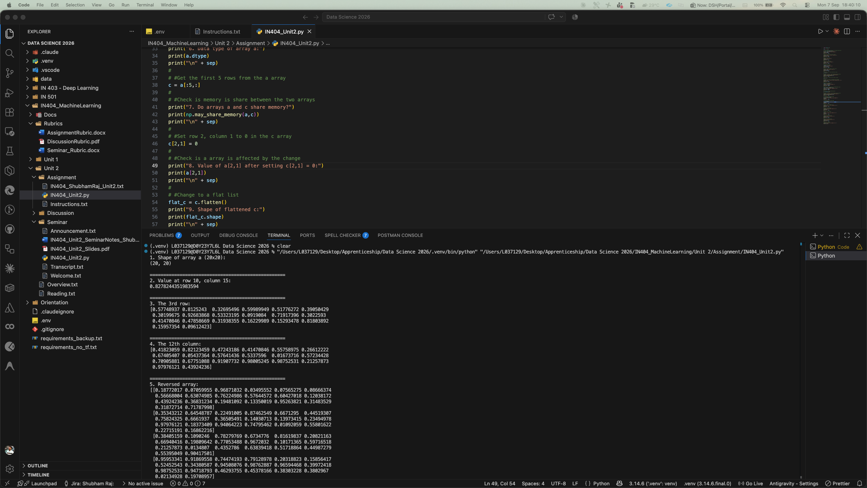
Figure 1: Code execution output (screenshot 1 of 3)

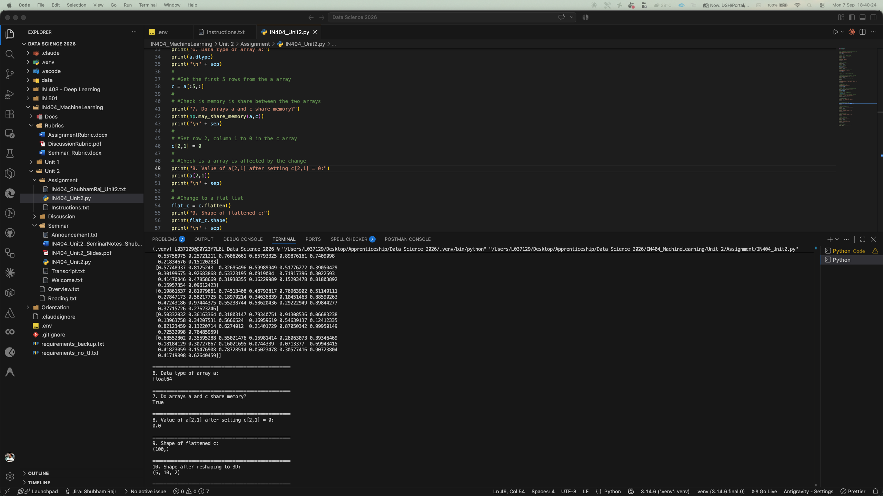
Figure 2: Code execution output (screenshot 2 of 3)

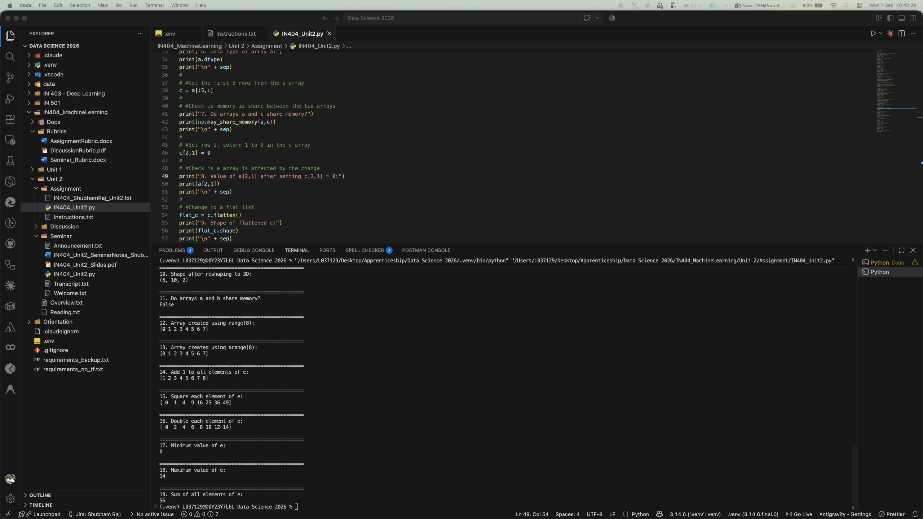
Figure 3: Code execution output (screenshot 3 of 3)

References
Géron, A. (2019). Hands-on machine learning with Scikit-Learn, Keras, and TensorFlow (2nd ed.). O'Reilly Media.
Matplotlib Documentation. (n.d.). Matplotlib: Visualization with Python. https://matplotlib.org/stable/
Najafi-Ghobadi, S., Najafi-Ghobadi, K., Tapak, L., & Aghaei, A. (2019). Application of data mining techniques and logistic regression to model drug use transition to injection: A case study in drug use treatment centers in Kermanshah Province, Iran. Substance Abuse Treatment, Prevention, and Policy, 14, Article 55. https://doi.org/10.1186/s13011-019-0242-1
NumPy Documentation. (n.d.). NumPy: The fundamental package for scientific computing with Python. https://numpy.org/doc/stable/
Paintsil, E. K., Omari-Sasu, A. Y., Addo, M. G., & Boateng, M. A. (2019). Analysis of haematological parameters as predictors of malaria infection using a logistic regression model: A case study of a hospital in the Ashanti Region of Ghana. Malaria Research and Treatment, 2019, Article 1486370. https://doi.org/10.1155/2019/1486370
Pandas Documentation. (n.d.). Pandas: Powerful data analysis toolkit. https://pandas.pydata.org/docs/
Raschka, S., & Mirjalili, V. (2019). Python machine learning (3rd ed.). Packt Publishing.
Russell, S., & Norvig, P. (2021). Artificial intelligence: A modern approach (4th ed.). Pearson.
Scikit-learn Documentation. (n.d.). Scikit-learn: Machine learning in Python. https://scikit-learn.org/stable/
SciPy Documentation. (n.d.). SciPy: Fundamental algorithms for scientific computing in Python. https://scipy.org/
Zhang, Y., Qu, H., Wang, W., & Zhao, J. (2020). A novel fuzzy time series forecasting model based on multiple linear regression and time series clustering. Mathematical Problems in Engineering, 2020, Article 9546792. https://doi.org/10.1155/2020/9546792
Zhao, R., Gu, X., Xue, B., Zhang, J., & Ren, W. (2018). Short period PM2.5 prediction based on multivariate linear regression model. PLoS ONE, 13(7), Article e0201011. https://doi.org/10.1371/journal.pone.0201011
Zheng, A., & Casari, A. (2018). Feature engineering for machine learning. O'Reilly Media.

